Rotation/Revolution Test – Do not write on me!

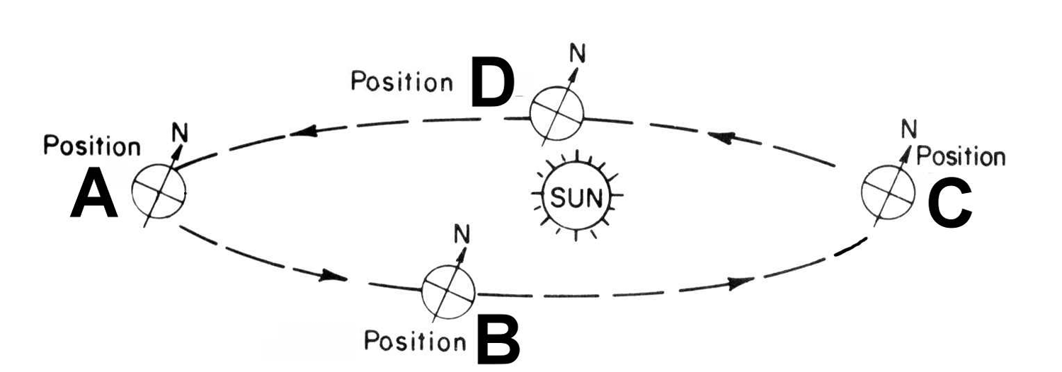
Define the following words:
- Hemisphere
- Constellation
- Axis
- Rotation
- Revolution
- Solstice
- Equinox
- Polaris

- What causes night and day?

10.) When it is summer in the northern hemisphere, it is winter in the southern hemisphere.
The opposite is true 6 months later. Write an explanation for why this occurs, using the following word bank: Polaris, 23.5 degrees, tilt, revolution (or revolve)

- What causes night and day?

Northern Hemisphere
11.) Season at position A
12.) Season at position B
13.) Season at position C
14.) Season at position D
Southern Hemisphere
15.) Season at position A
16.) Season at position B
17.) Season at position C
18.) Season at position D

