Review sheet for science quiz next class – Do this, then study!!!!
In each box below, write in which season each hemisphere is experiencing.
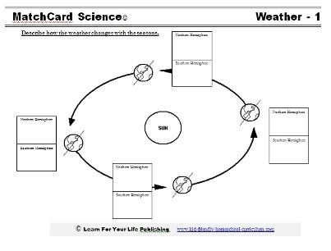
4
3
8
7
6
5
2
1
For each of these words, write the definition, using either your journal, your online textbook, or the internet (google); use the back of this sheet or a separate sheet of paper.
- Hemisphere
- Constellation
- Axis
- Rotation
- Revolution
- Solstice
- Equinox
- Polaris
17. When it is summer in the northern hemisphere, it is winter in the southern hemisphere. Write an explanation, using the following word bank: tilt, Polaris, axis, 23.5 degrees, revolution
18.) What causes night and day?

